SPRINT - 1

|  |  |
| --- | --- |
| **TEAM ID** | **PNT2022TMID8373** |
| **PROJECT NAME** | **IOT BASED SMART CROP PROTECTION SYSTEM FOR AGRICULTURE.** |
| **MAX MARKS** | **20 MARKS** |

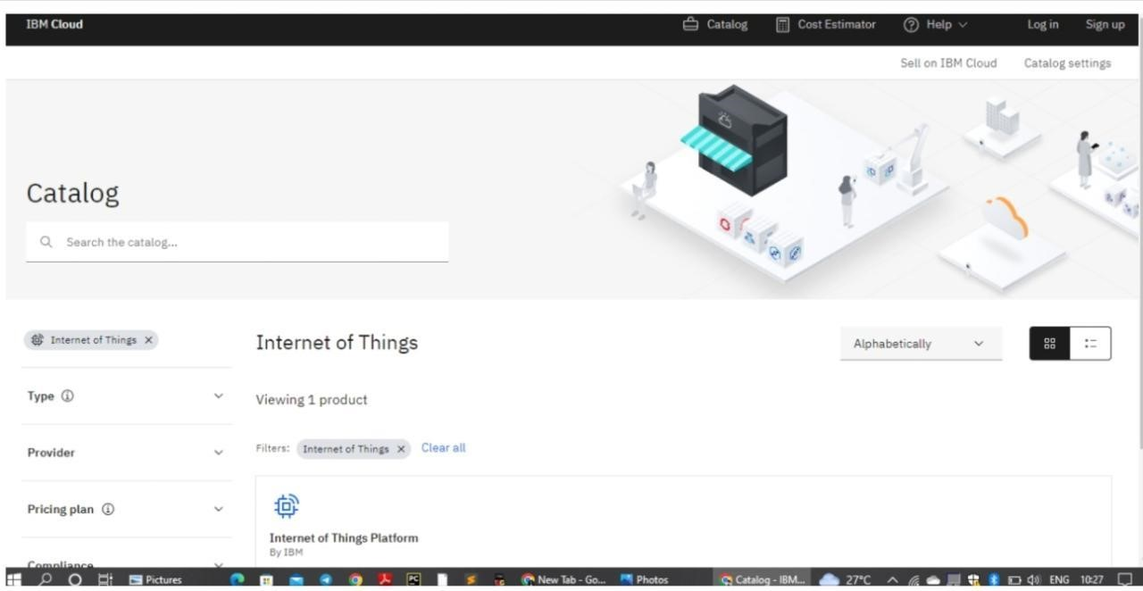

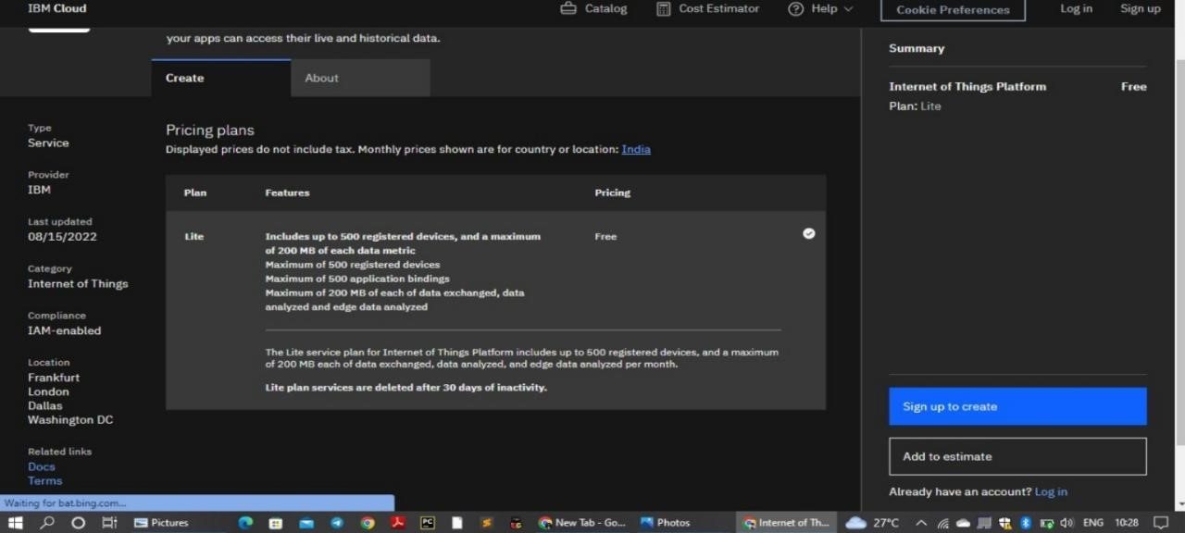

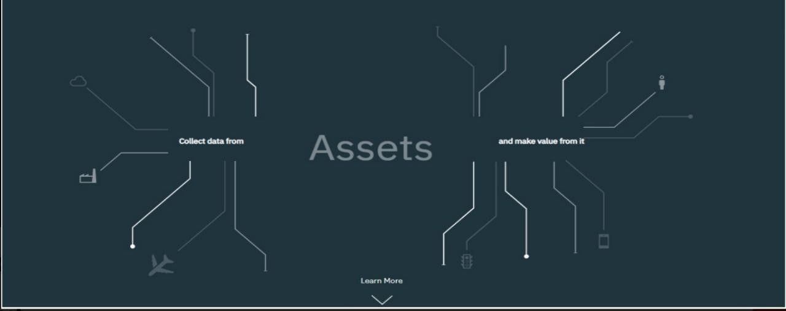

**DEVICE CREDENTIALS INFORMATION :**

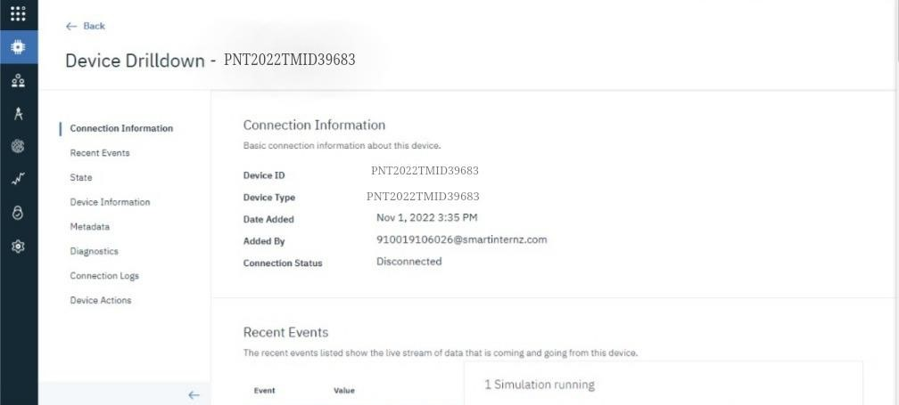

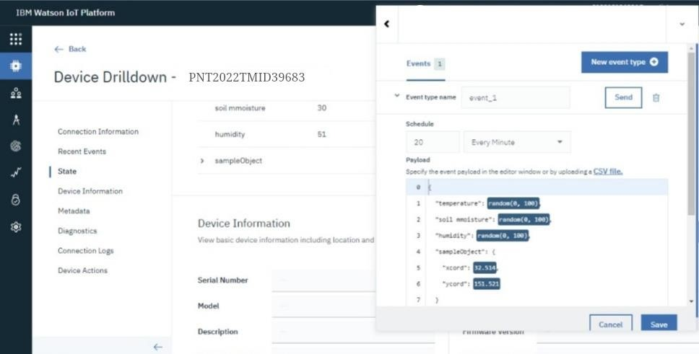

**OUTPUT :**

